Change Order Request
June 22, 2015

Merrill Gardens at Ballard, LLC
111 N. Post, Suite 200
Spokane, WA 99201
Attn: Bill Robinson

Re: Merrill Gardens at Ballard – Change Order Request #02 – RFI-061 Added Eyewash Stations

Bill,

Per RFI-061, cost for 2ea added eyewash stations with associated hot/cold water rough-in is $2,741 + 10% OH&P = $3,015. See breakdown of costs below.

Please note that the RFI does not specify where to install the eyewash in the commercial kitchen. As you can see in our breakdown, we’ve included a budget for the Guardian G1849 swing-down style eyewash, and are assuming that the engineer or architect will specify a location at a later date.

Please issue an official Change Order at your earliest convenience. Let me know if you have any questions or require further information. Thank you.

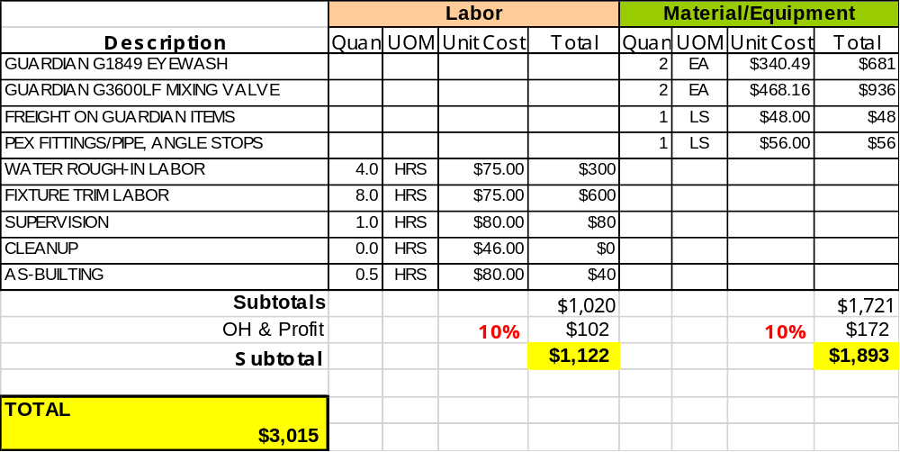

Sincerely,
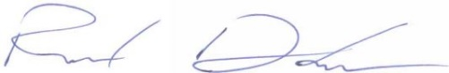
Richard Donelson
Project Manager / Estimator
richd@owpllc.net
425-591-4296 cell

